1. Identify the rating distribution in the Shop_Nest dataset, showcasing ratings categorized as Excellent, Very Good, Good, Bad, and Very Bad, along with corresponding orders.

Ans:

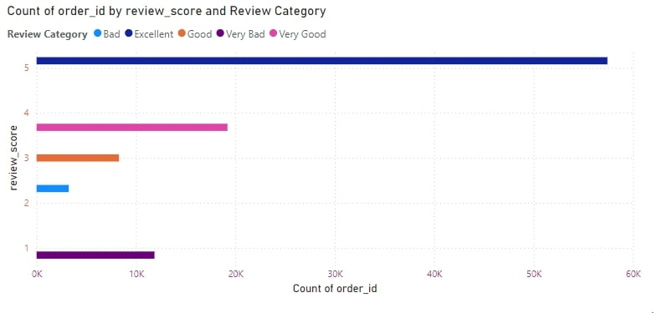

The shared graph in Power BI showing the **Count of order_id** across different **review_score** values, categorized by **Review Category**. Here's a breakdown for the graph:

### **Key Elements of the Graph:**

1. **Y-axis (review_score):**
   1. The vertical axis represents the numerical score for reviews ranging from 1 to 5.
2. **X-axis (Count of order_id):**
   1. The horizontal axis shows the total number of orders associated with each review score.
3. **Legend (Review Category):**
   1. This part categorizes reviews into several levels:
      1. Bad
      2. Excellent
      3. Good
      4. Very Bad
      5. Very Good
4. **Visualization Breakdown:**
   1. **5 stars (Review Score 5)** dominate the graph with the highest number of orders, categorized as "Very Good" (pink bar).
   2. **4 stars (Review Score 4)** follow next with fewer orders, categorized as "Good" (light purple).
   3. **3 stars (Review Score 3)** have a smaller count of orders, categorized as "Bad" (orange).
   4. **2 stars (Review Score 2)** and **1 star (Review Score 1)** have the least orders, categorized as "Very Bad" (dark purple for 1-star and blue for 2-star reviews).

### **Insights:**

* The majority of orders received a **5-star rating**, reflecting customer satisfaction.
* The significant drop in orders from 5 stars to lower review scores (especially for 1 and 2 stars) indicates that most customers are either very satisfied or do not rate poorly.

### **Explanation:**

This bar chart displays the count of order IDs for each review score, categorized by the review labels like ‘Very Good,’ ‘Good,’ ‘Bad,’ and others. From the visualization:

* A large majority of orders received a **5-star review** and are categorized under ‘Very Good.’ This indicates that a significant portion of customers are highly satisfied with their purchase experience.
* **4-star reviews** are next in count, categorized as ‘Good,’ showing relatively positive customer feedback but with room for minor improvements.
* The number of orders receiving **1-star** and **2-star** reviews, categorized as ‘Very Bad’ and ‘Bad,’ is considerably lower, suggesting fewer instances of dissatisfaction.
* **Key Insight:** There is a clear trend of higher customer satisfaction (5 stars) dominating the order reviews, while negative reviews (1-2 stars) form a small portion of the total dataset

2. What are the top 10 and bottom 18 most popular product categories in the ShopNest dataset? Please list them based on the number of orders.

Ans:

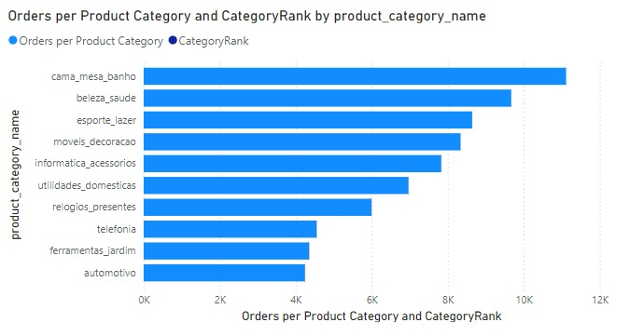

### **Question Statement:**

What is the distribution of orders per product category, and how do the categories rank based on the number of orders?

### **2. Visualization:**

The provided bar chart represents the "Orders per Product Category and CategoryRank" by the product category name. This chart uses two metrics:

* **Orders per Product Category** (represented by blue bars)
* **CategoryRank** (represented by the grey bars)

In the bar chart, the product categories are listed on the y-axis, while the x-axis shows the number of orders. The length of each bar indicates the total orders per category.

### **3. Explanation:**

* **Key Insights**:
  + The product category "Cama Mesa Banho" (Bedding, Table, Bath) ranks highest in terms of total orders, with approximately 10,000 orders.
  + The second category is "Beleza Saude" (Beauty and Health), followed closely by "Esporte Lazer" (Sports and Leisure), each with a bit less than 10,000 orders.
  + Categories like "Automotivo" (Automotive) and "Ferramentas Jardim" (Garden Tools) rank at the bottom, receiving far fewer orders (under 4,000).
* **Additional Observations**:
  + The graph provides clear insights into which product categories are performing best and which may need more attention or targeted marketing strategies.
  + There's a noticeable gap between the top categories ("Cama Mesa Banho" and "Beleza Saude") and the bottom-ranking ones ("Automotivo" and "Ferramentas Jardim").
* The bar graph shows the number of orders across different product categories, providing a clear ranking of these categories based on the total number of orders. "Cama Mesa Banho" leads with the highest number of orders, followed closely by "Beleza Saude" and "Esporte Lazer." Categories such as "Automotivo" and "Ferramentas Jardim" have significantly fewer orders, ranking at the bottom. This visualization helps identify top-performing categories and highlights areas that might need strategic focus for improvement. The graph offers a quick overview of how each category contributes to the overall sales.

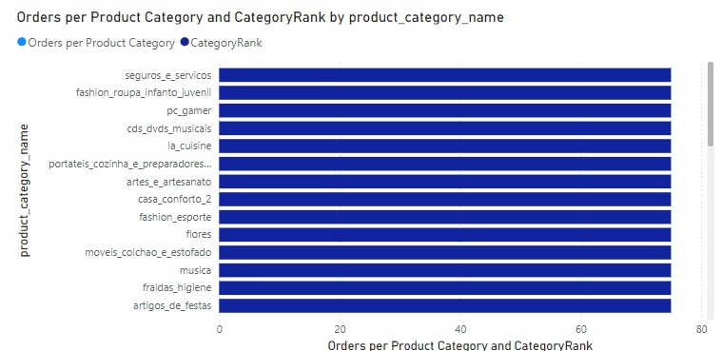

**Bar Graph Explanation:**

#### **Visualization:**

The bar graph represents **"Orders per Product Category and CategoryRank by product_category_name."** It shows two key metrics for different product categories:

1. **Orders per Product Category** (blue circles).
2. **Category Rank** (blue bars).

The product categories include items like "seguros_e_servicos," "fashion_roupa_infanto_juvenil," "pc_gamer," and several others, listed on the vertical axis. The horizontal axis measures the corresponding number of orders or rank values (likely ranging from 0 to 80).

#### **Key Insights:**

1. **Uniformity**: Each product category has the same bar length (around 80), suggesting that the category ranks are consistent across all items. This implies a possible normalization in rank assignments or uniform popularity across categories.
2. **Product Categories**: Categories such as **seguros_e_servicos** (insurance services), **pc_gamer** (gaming equipment), **la_cuisine** (kitchen items), and **fashion_esporte** (sports fashion) are included, indicating a wide range of products.
3. **Rank Distribution**: The uniform bar lengths could imply that category rankings are standardized or that all categories rank highly.

#### **Explanation of Insights:**

* The visualization aims to compare product category performance based on orders and rank, but it appears to present an identical rank value for each category.
* If intended, this could indicate equal popularity or a flaw in the rank metric.
* To improve insights, it might be helpful to investigate whether the ranks are meant to vary or if further analysis could break down orders per category more meaningfully.

3. List the total number of active sellers by yearly and monthly.

Ans:

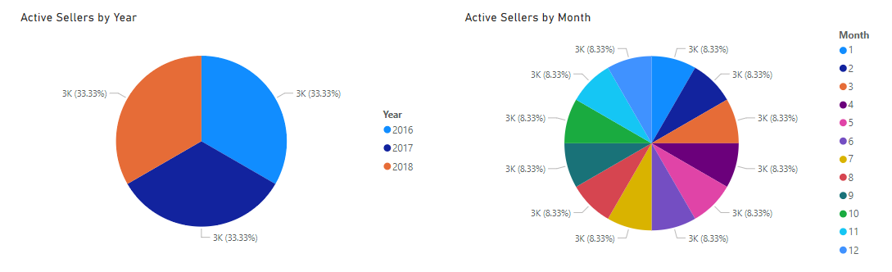

#### **Explanation of the Visuals**

#### **1. Active Sellers by Year (Pie Chart)**

Description: This pie chart represents the distribution of active sellers across three years: 2016, 2017, and 2018. Each segment of the pie corresponds to the total number of active sellers for each year, with each year accounting for 33.33% of the total.

Data Points:

2016: 3,000 active sellers

2017: 3,000 active sellers

2018: 3,000 active sellers

Visual Representation: Each year has an equal share in the pie chart, indicating a stable number of active sellers across these years.

#### **2. Active Sellers by Month (Pie Chart)**

Description: This pie chart displays the distribution of active sellers for each month over a year. Each slice of the pie represents the total number of active sellers for a specific month.

#### **Data Points:**

Each month (from January to December) shows 3,000 active sellers, accounting for 8.33% of the total.

Visual Representation: The chart is divided into 12 equal parts, indicating that the number of active sellers is consistent throughout the year.

#### **Business Insights**

#### **Stability in Seller Count:**

#### 

The equal distribution of active sellers across the years suggests that the business has maintained a stable base of sellers. This stability can indicate effective seller engagement and retention strategies, which are crucial for sustained business growth.

Consistent Monthly Activity:

The monthly chart shows a constant number of active sellers throughout the year. This consistency can imply that sellers remain engaged year-round, which is beneficial for continuous sales and customer service.

Opportunities for Seasonal Promotions:

Although the number of active sellers is consistent, analyzing sales data alongside seller activity can reveal if certain months generate higher sales. If there are peaks in sales during specific months, it could be advantageous to create promotional campaigns to drive more activity from sellers during slower months.

Focus on Seller Acquisition and Support:

With a stable number of sellers, the business might consider initiatives to expand this base. Strategies could include targeted marketing campaigns to attract new sellers or support programs to help existing sellers grow their businesses, thus potentially increasing their sales volume.

Long-Term Growth Strategies:

Monitoring trends in seller activity over additional years may help identify patterns that could influence strategic decisions. For instance, if seller activity begins to decline in future years, it may warrant investigation into the factors driving seller engagement.

4. Which payment methods are most commonly used by ShopNest customers.

Ans:

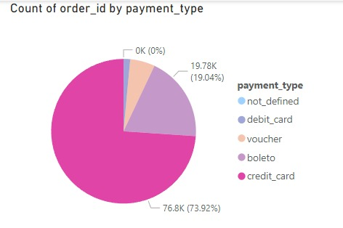

### **Pie Chart Explanation:**

#### **Visualization:**

This pie chart illustrates the **"Count of order_id by payment_type."** It shows the distribution of various payment types used in the orders and their respective percentages.

The payment types include:

1. **Credit Card** (magenta)
2. **Boleto** (a popular Brazilian payment method, light purple)
3. **Voucher** (light pink)
4. **Debit Card** (blue)
5. **Not Defined** (light gray)

The corresponding order counts and percentages for each payment type are listed in the legend on the right-hand side.

#### **Key Insights:**

1. **Credit Card Dominance**:
   1. Credit cards account for the majority of transactions, with **76.8K orders**, which is **73.92%** of the total.
2. **Boleto Payment**:
   1. The second most popular payment method is **Boleto**, with **19.78K orders**, making up **19.04%** of total orders.
3. **Other Payment Methods**:
   1. **Voucher** and **Debit Card** together contribute less than **7%** of total transactions.
   2. **Not Defined** payments are negligible, contributing **0%**.
4. **Low Variety in Payment Options**:
   1. The chart suggests that consumers primarily use **credit cards** and **Boleto**, while other payment options such as **debit cards** and **vouchers** play a minor role in the overall transaction volume.

#### **Explanation of Insights:**

This pie chart highlights the heavy reliance on **credit cards** as the dominant payment method, with **Boleto** being a distant second. It indicates that most customers prefer credit card payments for their orders. Payment methods like **vouchers** and **debit cards** are used minimally, suggesting potential areas to encourage diverse payment adoption. Understanding why some methods, like **debit cards**, are underutilized could lead to more targeted strategies for improving payment method variety.

5. Identify the product category. wise profit margin using the formula

Hint: (Payment value -price + Freight_value)/payment_value*100 (Rounded to two decimal points).

Ans:

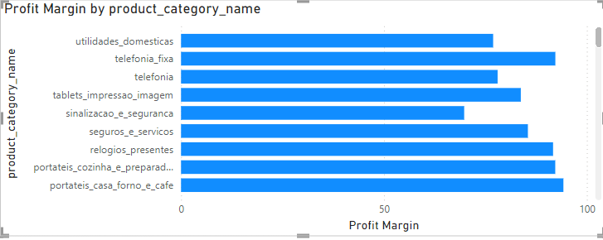

#### **Explanation of the Visual**

#### **Profit Margin by Product Category (Bar Chart)**

***Description:*** This bar chart illustrates the profit margins associated with various product categories. Each bar represents a specific product category, and the length of the bar correlates to the profit margin percentage, which ranges from 0% to 100%.

***Data Points:***

The categories listed show varying profit margins, indicating the relative profitability of each category.

Some categories have high profit margins (e.g., fashion, electronics), while others may have lower margins.

Visual Representation: The bars are color-coded uniformly (blue), making it easy to compare the length of the bars visually.

***Business Insights***

***Identifying High-Profit Categories:***

Categories with higher profit margins are prime candidates for marketing efforts and promotional activities. Focusing on these categories can lead to increased revenue and profit for the business.

***Cost Management:***

Understanding the profit margins can help the business evaluate cost structures. Categories with low profit margins might require a review of their pricing strategies, production costs, or supply chain efficiencies to improve profitability.

***Product Development Decisions:***

Insights from this visual can guide future product development. If certain categories consistently show higher profit margins, the business might choose to expand product lines within those categories or enhance features to maximize profitability.

***Marketing Strategies:***

The business can tailor marketing strategies based on the profitability of each category. For instance, campaigns could highlight products in high-margin categories to attract customers and drive sales.

***Inventory Management:***

Categories with low profit margins may suggest the need for careful inventory management. The business might consider reducing stock levels for lower-margin items or finding ways to improve their profitability.

***Addressing the "Blank" Category:***

The presence of a "(Blank)" category suggests there are products without specified categories, which could lead to missed opportunities for analysis. Identifying and categorizing these products could provide additional insights into potential profitability.

***Conclusion***

This visual provides valuable insights into the profitability of different product categories, allowing the business to make informed decisions on marketing, product development, and cost management. By leveraging this information, the business can enhance its profitability and strategic planning, ensuring a more effective approach to product offerings.

6. Determine the monthly payments made by customers using credit cards.

Ans:

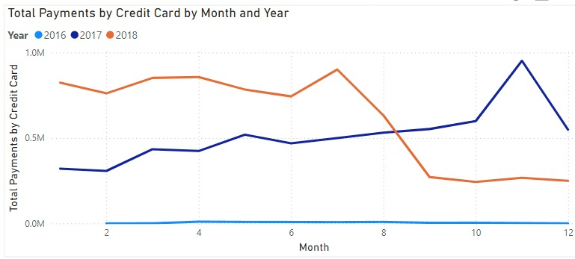

### **1. Question Statement**

* **Question**: What are the trends in total credit card payments over time, categorized by month and year from 2016 to 2018?

### **2. Visualization**

* The line graph shows the total payments made using credit cards, plotted against the months for three different years: 2016, 2017, and 2018.
* **Legend**:
  + **2016**: Light blue line.
  + **2017**: Dark blue line.
  + **2018**: Orange line.
* The y-axis represents the total payments made by credit card (in millions), and the x-axis shows the months of the year (1 to 12).

### **3. Explanation**

The graph highlights a comparison of credit card payment trends over three years (2016, 2017, and 2018):

* **2018** has the highest total payments, especially from March to June and in November, with a peak in November.
* **2017** shows relatively stable total payments throughout the year, with a slight peak in May and a sharp increase in November and December.
* **2016** has the lowest total payments, staying consistently below 0.1 million throughout the year, with minimal fluctuations.

#### **Key Insights:**

* There is a clear upward trend in total credit card payments from 2016 to 2018, particularly in mid-year and towards the end of the year.
* **Seasonality** can be observed, with spikes in **November** each year, possibly due to holiday-related spending.
* 2018 shows a more pronounced dip around September before sharply rising again in November, while 2017 maintains more consistent growth.

The graph emphasizes that credit card payments have increased over time, with clear seasonal peaks.

7. Identify sellers categorized by city, excluding cities starting with the letters S and B.  
  
Ans:

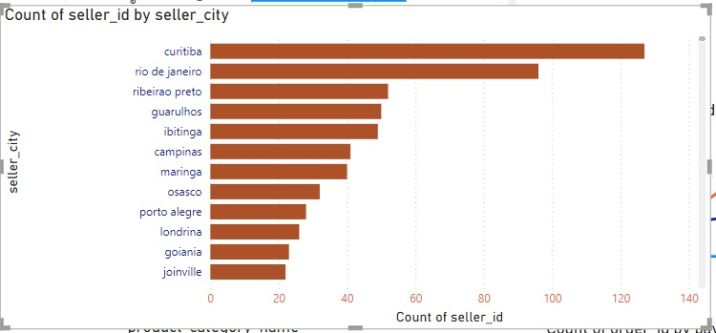

#### **Count of Seller IDs by Seller City (Bar Chart)**

Description: This bar chart displays the number of sellers (indicated by the count of seller_id) in various cities. The data has been filtered to exclude cities that start with the letters "S" and "B", providing a clearer focus on other cities.

#### **Data Points:**

Each bar represents a city, with the height of the bar corresponding to the number of sellers in that city.

The cities listed include Curitiba, Rio de Janeiro, Ribeirão Preto, Guarulhos, Ibitinga, Campinas, Maringa, Osasco, Porto Alegre, Londrina, Goiânia, and Joinville.

***Visual Representation:*** The bars are colored uniformly (brown), which helps in comparing the number of sellers across different cities.

***Business Insights***

***Top City for Sellers:***

Curitiba has the highest number of sellers, indicating it may be a strong market for sales and services. This suggests potential for increased marketing efforts or partnerships in this region.

***Market Potential:***

Cities like Rio de Janeiro and Ribeirão Preto also have significant counts of sellers, indicating these areas may have robust economic activity. Businesses may consider expanding operations or focusing marketing strategies in these regions.

***Seller Distribution:***

The visual reveals how seller distribution is uneven across cities. This information can help in identifying regions with fewer sellers, suggesting opportunities for growth or targeted outreach to potential sellers in those areas.

***Resource Allocation:***

Understanding where the majority of sellers are located allows for strategic resource allocation. The business can focus more on logistics, support, and services in cities with higher seller counts.

***City-Specific Strategies:***

Different cities may have varying market dynamics. Tailoring strategies based on the number of sellers can help in addressing local customer preferences and enhancing seller performance.

***Exclusion of Certain Cities:***

By excluding cities starting with "S" and "B", the visual focuses on other potentially underserved markets. This strategic choice can uncover hidden opportunities in cities that may not typically receive the same level of attention.

***Conclusion***

This visual provides critical insights into seller distribution across cities, allowing the business to make informed decisions regarding marketing strategies, resource allocation, and growth opportunities. By leveraging the data presented, the business can enhance its operational efficiency and better cater to the needs of its sellers and customers.